SIMATS ENGINEERING ASSESSMENT TOOL 2
COURSE NAME: COMPUTER NETWORKS
COURSE CODE: CSA07
COURSE OUTCOME COVERED
CO4:
Design network topologies star, mesh, bus, and hybrid using networking devices, transmission media, and cabling standards (BL2,BL6)
Assessment Tool Weightage: 30%
Annexure A
Industry Problem Solving Task
Code of Conduct:
I __sanjay Charan s(192312373)_______ (Name / Reg No) certify that this submission is my original work and that I have adhered to the guidelines specified for this assessment.
I understand that any violation of academic integrity rules will result in disciplinary action.
Signature of the student: charan

Annexure A
Industry Problem Solving Task
1. Star Topology for a 20-Person Startup
Answer
A Star Topology is the best network design for a startup office with around 20 employees because every device is connected to a central network switch. This centralized structure makes the network easy to install, maintain, and expand as the company grows. If one cable or device fails, only that particular device is affected, while the rest of the network continues to function normally.
- In this setup, a 24-port Layer 2/Layer 3 managed switch acts as the central connection point. All computers, printers, VoIP phones, and a Wi-Fi access point are connected to the switch using Cat6 UTP cables, which provide speeds of up to 1 Gbps over distances of 100 meters. The switch is connected to a router/firewall, which provides internet access, DHCP, Network Address Translation (NAT), and security features.
Components Used
- 24-Port Managed Switch.
- Router/Firewall.
- 20 Desktop or Laptop Computers.
- Network Printers.
- VoIP Phones.
- Wi-Fi Access Point.
- Cat6 UTP Ethernet Cables.
Advantages
- Easy to manage and troubleshoot.
- Failure of one cable does not affect other devices.
- High-speed Gigabit communication.
- Easy to add new devices without interrupting the network.

Conclusion
- Star topology provides reliability, fault isolation, scalability, and better performance, making it the most suitable topology for small and medium-sized business offices.

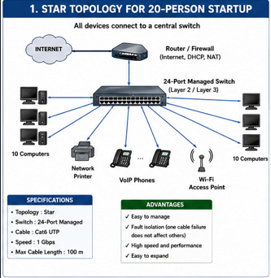

2. Mesh Topology for a Banking Network
Answer
A Mesh Topology is the most reliable network design for banks because banking systems require continuous connectivity and near-zero downtime. In a mesh network, important devices such as routers, core switches, and servers are connected through multiple communication paths. If one link fails, traffic is automatically redirected through another available path.
Large banks usually implement a partial mesh at the core layer, where multiple core switches, firewalls, and routers are interconnected using fiber optic cables. Dual enterprise routers provide redundant internet connections, while routing protocols such as OSPF and BGP ensure automatic path selection and failover. Fiber optic cables are preferred because they offer very high bandwidth, low latency, and immunity to electromagnetic interference.
Components Used
- Core Routers.
- Core Layer Switches.
- Distribution Switches.
- Firewalls.
- Application and Database Servers.
- Fiber Optic Links.
- UPS and Redundant Power Supplies.
Advantages
- No single point of failure.
- High availability and reliability.
- Automatic traffic rerouting during failures.
- Secure communication for financial transactions.

Conclusion
Mesh topology ensures uninterrupted banking services, protects sensitive financial data, and meets the high availability requirements of modern banking systems.

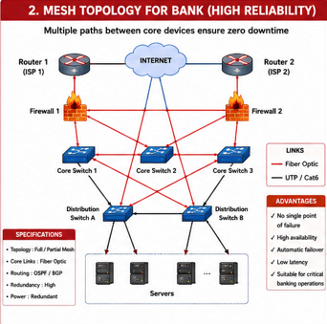

3. Bus Topology for a Classroom Computer Lab
Answer
A Bus Topology is an economical network design suitable for a small classroom computer laboratory where the primary objective is to reduce installation costs. All computers communicate through a single shared backbone cable, eliminating the need for expensive networking equipment.
In a traditional bus network, computers connect to an RG-58 coaxial cable using BNC T-connectors, and 50-ohm terminators are installed at both ends to prevent signal reflection. In modern classroom setups, a small unmanaged switch with Cat5e or Cat6 cables is often used because it is inexpensive and easier to maintain.
Components Used
- RG-58 Coaxial Cable.
- BNC T-Connectors.
- 50-Ohm Terminators.
- Computers.
- Optional Unmanaged Switch.
- Cat5e/Cat6 Ethernet Cables.
Advantages
- Low installation cost.
- Simple network setup.
- Requires minimal networking hardware.
- Suitable for small classrooms.
Limitations
- Entire network stops if the backbone cable is damaged.
- Data collisions increase when many users transmit simultaneously.
- Difficult to troubleshoot large networks.
Conclusion
Bus topology is a budget-friendly solution for classroom environments where network traffic is light and maintenance is supervised.

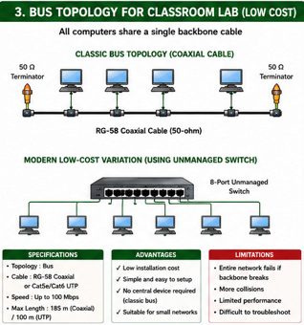

4. Hybrid Topology for a University Campus
Answer
A Hybrid Topology combines different network topologies to provide a scalable and reliable network for a large university campus. Since universities contain multiple buildings, laboratories, libraries, hostels, and administrative offices, a single topology cannot efficiently meet all networking requirements.
The campus backbone uses a fiber optic ring or partial mesh to connect core routers and multilayer switches. Each building has a distribution switch connected to the backbone through dual fiber uplinks for redundancy. Inside each building, Star Topology is used to connect access switches, computers, printers, IP phones, and wireless access points through Cat6 cables. Wireless access points receive power through Power over Ethernet (PoE).
Three-Layer Architecture
- Core Layer – High-speed backbone connecting all buildings.
- Distribution Layer – Connects each building to the campus backbone.
- Access Layer – Connects end-user devices.
Advantages
- Highly scalable for thousands of users.
- Redundant backbone prevents network failure.
- Easy expansion by adding new buildings.
- High-speed communication using fiber optics.
- Supports wired and wireless connectivity.
Conclusion
Hybrid topology provides the flexibility, redundancy, and scalability required for large educational institutions with multiple buildings and thousands of users.

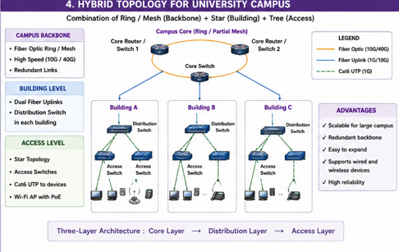

5. Network Design for a Company with Multiple Departments
Answer
A company with departments such as HR, Finance, Sales, and IT requires a structured network that provides both communication and security. A Hierarchical Star Topology with Virtual LANs (VLANs) is commonly used because it logically separates departmental traffic while allowing controlled communication between departments.
Each department is connected to a Layer 2 access switch. These switches connect to a Layer 3 core switch, which performs inter-VLAN routing so departments can communicate securely when required. A router/firewall connects the internal network to the internet and provides security features such as firewall filtering, NAT, and VPN access.
VLAN Configuration Example
Department | VLAN ID | Subnet
HR | 10 | 192.168.10.0/24
Finance | 20 | 192.168.20.0/24
Sales | 30 | 192.168.30.0/24
IT | 40 | 192.168.40.0/24
Components Used
- Layer 2 Access Switches.
- Layer 3 Core Switch.
- Router/Firewall.
- Servers.
- Cat6 Ethernet Cables.
- Wireless Access Points.
Advantages
- Improved security through VLAN separation.
- Reduced broadcast traffic.
- Efficient communication between departments.
- Easy network expansion and management.
- Supports centralized monitoring and access control.
Conclusion
A VLAN-based hierarchical network provides better performance, stronger security, and easier management, making it an ideal design for organizations with multiple departments and future growth plans.

